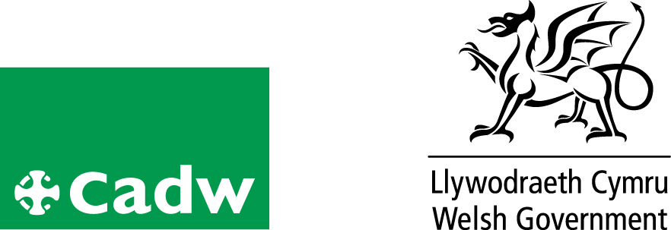
Volunteer role profile

Volunteer Tour Guide
Location | Plas Mawr
Volunteer Manager
Role Description | - To deliver a site tour to visitors in a warm and friendly manner  - To respond accordingly to the various needs and interests of the different visitors.  - To help us deliver enhance the visitor experience  - To actively engage with visitors conveying the story of Plas Mawr and Robert Wynn  - To be part of the public face of Cadw
Qualifications/ Special Skills | No formal qualifications required
Days | Monday – Sunday inclusive
Time | As and when required
Essential |  | Desirable
Good Communication skills |  | Welsh Speaker
Ability to work unsupervised
Friendly and approachable |  | Interest in history/architecture primarily the Tudor/Stuart periods
Reliable, responsible and punctual |  | .
 |  | Guiding experience
Probation period |  | A minimum of 6 tours
Volunteer Benefits |  | • Training  • Experience of working in Heritage  • Meet new people with similar interests  •Become part of a team
Training |  | Full training will be given
Expenses |  | Reasonable cost of travel between home and place of volunteering will be paid. Other reasonable expenses must be agreed in advance
This is a voluntary role, binding in honour only and is not legally binding
Contact:
Tel:01492580167/573605
e-mail:plasmawr@wales.gsi.gov.uk

