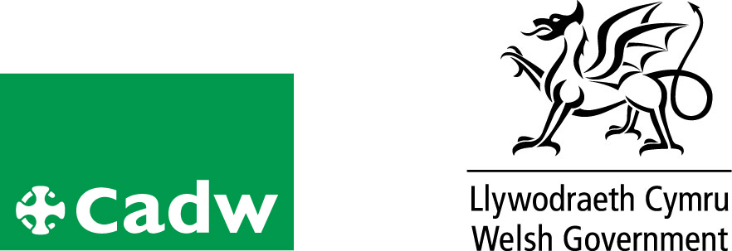
Volunteer role profile

Volunteer Tour Guide
Location | Conwy Castle
Volunteer Manager | Roy Williams
Role Description | - To deliver a site tour to visitors in a warm and friendly manner  - To respond accordingly to the various needs and interests of the different visitors.  - To help us deliver enhance the visitor experience  - To actively engage with visitors conveying the story of Conwy Castle  - To be part of the public face of Cadw
Qualifications/ Special Skills | No formal qualifications required
Days | Monday – Sunday inclusive
Time | As and when required
Essential |  | Desirable
Good Communication skills |  | Welsh Speaker
Ability to work unsupervised |  | Interest in history/architecture and in particular the Edward 1 period and Age of the Princes
Friendly and approachable |  | Guiding experience
Reliable, responsible and punctual |  | .
Probation period |  | A minimum of 6 tours
Volunteer Benefits |  | • Training  • Experience of working in Heritage  • Meet new people with similar interests  •Become part of a team
Training |  | Full training will be given
Expenses |  | Reasonable cost of travel between home and place of volunteering will be paid. Other reasonable expenses must be agreed in advance
This is a voluntary role, binding in honour only and is not legally binding
Contact:
Tel: Tel 01492 592358
E-mail: conwycastle@gov.wales

