Staffed Site Educational Visit – Example Risk Assessment
Cadw is committed to welcoming Educational Visits back to our sites. The majority of sites are available to book via out online booking system. Please ensure that the current guidance is read before booking.
All educational institutions visiting a Cadw site must submit a risk assessment, if they have not already written one they are able to use this template, and submit it to the monument they wish to visit at least two weeks before visiting. Cadw are offering the risk assessor the opportunity to attend site before the visit in order to assist them with populating their school visit risk assessment; ready for EVOLVE submission.
Cadw offers free pre inspection visits to support your development of your risk assessment. This document is for your guidance only, you remain responsible for your risk assessment and any omissions
If multiple site visits are being booked, only the one risk assessment would be required as long as the circumstances of the visits are similar e.g. group size, transport to site etc.
Please see the guidance at the bottom of this template on completing the risk assessment and the measures we expect to be in place to keep our staff and other visitors safe throughout your visit.
Booking Details
Cadw Site Attending
Institution Name
Booking Number
Risk Assessor and Contact Details
Date of Visit
Number of Individuals attending site (include students, teachers, chaperones and drivers)

Risk Assessment Matrix
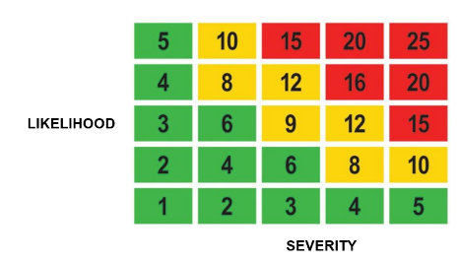 | Severity | Likelihood | High Risk: 15 to 25 – Activities should cease immediately until further control measures to mitigate the risk are implemented.  Medium Risk: 8 to 12 – Activities should only be tolerated for the short-term then only whilst further control measures to mitigate the risk are being planned and introduced, within a defined a time period  Low Risk: 1 to 6 – Largely acceptable, subject to reviews periodically, or after significant change.
 | 1 – No Injury | 1 – Unlikely
 | 2 – Minor Injury | 2 – Possible
 | 3 – Injury requiring Medical Treatment | 3 – Likely
 | 4 – Major Injury | 4 – Probable
 | 5 - Fatality | 5 - Certain

Hazard | Who Might be Harmed and How? | Control Measures in Place | Risk Rating | Further Control Measures Required | Residual Risk

