

**CADW: CHEPSTOW CASTLE**

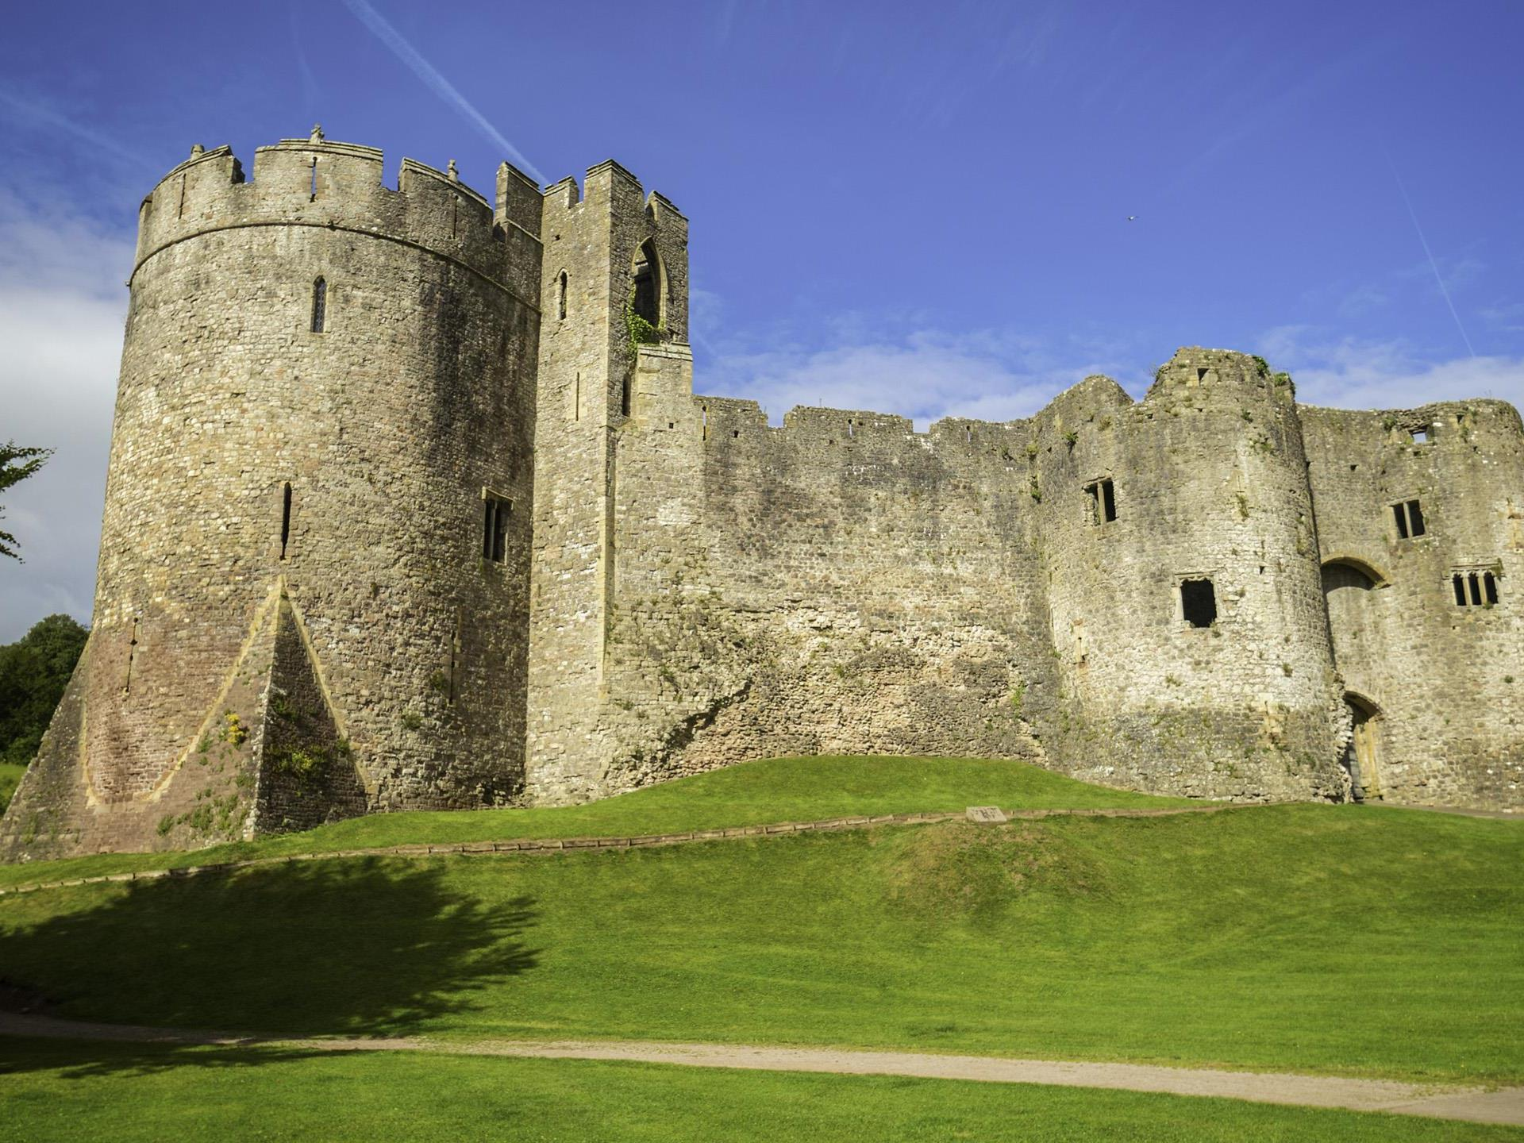

**Expressions of Interest INVITED**

**FROM Potential operators**

**for** **Chepstow castle mobile catering unit.**

**3 year AGREEMENT FROM APRIL 2023.**



**INTRODUCTION:**

Beautifully preserved Chepstow Castle stretches out along a limestone cliff above the River Wye like a history lesson in stone.

There’s no better place in Britain to see how castles gradually evolved to cope with ever more destructive weaponry – and the grandiose ambitions of their owners. For more than six centuries Chepstow was home to some of the wealthiest and most powerful men of the medieval and Tudor ages.

Building was started in 1067 by Earl William fitz Osbern, close friend of William the Conqueror, making it one of the first Norman strongholds in Wales. In turn William Marshal (Earl of Pembroke), Roger Bigod (Earl of Norfolk) and Charles Somerset (Earl of Worcester) all made their mark before the castle declined after the Civil War.

These magnates and powerbrokers were constantly on the move. Chepstow was just one residence in their vast estates – an impressive shell into which they would bring their gold and silver vessels, rich silk and brightly painted furniture.

Cadw is looking for an operator to run a pop-up, mobile catering unit inside the castle.

**CADW:**

Cadw, meaning ‘to keep’, works to conserve and protect the historic environment for Wales and to promote distinctive regeneration and sustainable development through heritage. We conserve Wales’ historic places for people to cherish and to enjoy, today and in the future, and we have responsibility for some of the most significant sites in the world. Cadw promotes the development of the skills that are needed to look after our historic environment, and we work together with partners to achieve our common goals.

We help sustain the distinctive character of Wales’s landscapes and towns, help people understand and care about their place and history and the place of Wales in the world, and we make a real difference to people’s wellbeing in Wales.

Cadw is responsible for the conservation, preservation and presentation of 130 monuments throughout Wales. Included in the estate is Chepstow Castle, which sits right on the border of Wales and England.

[Chepstow Castle | Cadw (gov.wales)](https://cadw.gov.wales/visit/places-to-visit/chepstow-castle)

[cadwwales - YouTube](https://www.youtube.com/user/cadwwales/videos)

**LOCATION:**

**Chepstow Castle:** Chepstow is a town and community in Monmouthshire, Wales, adjoining the border with Gloucestershire, England. It is located on the tidal River Wye, about 2 miles above its confluence with the River Severn, and adjoining the western end of the Severn Bridge.

Address: Chepstow Castle, Bridge St, Chepstow NP16 5EY

Road

From Cardiff M4, J23, M48 J2, A466. From London M4, J21 & M48.

Rail

Chepstow 1km/0.6mls Cardiff-Gloucester-Birmingham line.

Bike

NCN Route No.4 (200m/219yards).

Postcode: NP16 5EY.

**THE OPPORTUNITY:**

Cadw is offering a rare, notable and substantial opportunity, preferably for a local, independent, business to establish, run and manage the unique mobile catering facility at Chepstow Castle.

The Chepstow Castle pop-up catering unit is immediately available and it is hoped that from **1st April**, **2023**, this will be run by a third party operator selected, following this Expression of Interest process.

Please note. Power and water supply will be available at site. Operators should outline their thoughts on how the mobile unit could be run, when responding to this Expression of Interest.

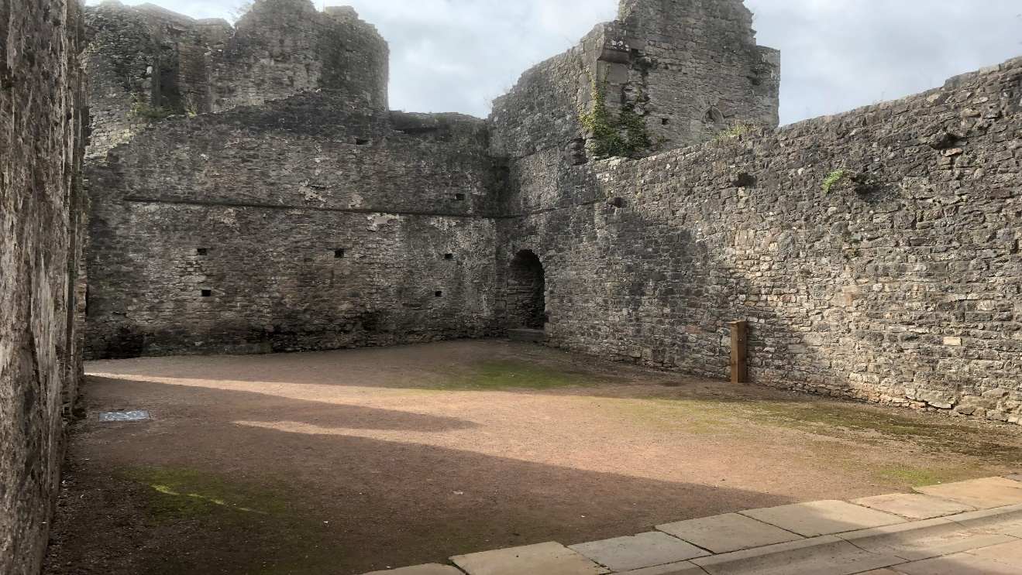

*The location within Chepstow Castle for the mobile catering unit.*

Cadw seeks to secure a professional catering operator, experienced in the operational demands of running a similar operation. The operator will provide a quality, attractive and professional, catering offer at Chepstow Castle to enable a friendly, fast and efficient customer service for our visitors to the Castle.

The Operator will need to meet the catering expectations and requirements of Cadw’s many varied visitor groups and to provide a top quality, enjoyable catering experience, which will add to their overall visitor experience at Chepstow Castle. They will also need to work closely with Cadw staff on site and with Cadw’s Commercial department, to deliver the service in line with Welsh Government requirements and expectations.

The occupational agreement for the pop-up catering facility at Chepstow Castle will start from 1st April, 2023 – 1st April, 2026, with a review after the first year, where either party can terminate the agreement. If the relationship between Cadw and the Operator proves successful, the three-year term will be able to be extended in line with normal Landlord and Tenant negotiations.

The annual license fee to be paid to Cadw is expected to be circa £5,000, per annum ex VAT. This fee will depend on how the successful operator recommends running the unit once trade figures available after year 1.

All utility charges, including water and electricity, used by Chepstow Castle mobile catering unit, will be the direct responsibility of the Operator. Cadw will invoice for utilities in addition to the monthly license fees.

The successful operator will be required to agree and sign an appropriate occupational agreement before occupation of Chepstow Castle can commence (final terms to be solely determined by Cadw). The agreement will be on the basis that the business tenant will not be entitled to statutory protection to renew the agreement.

The permitted use for Chepstow Castle catering area, situated within the space in what used to be the Great Hall of the castle and measures approximately 18m x 9m can be used for providing light refreshment facilities. Chepstow Castle catering area is situated within the pay barrier of this Cadw site and is to be open in conjunction with Chepstow Castle’s opening times.

The Chepstow Castle mobile catering unit is to open for any evening events which may arise, when asked to do so by Cadw, and to provide an out-of-hours catering service if required. The frequency and nature of these events will naturally vary and is likely to increase in number; currently this is approximately twenty nights, per annum, for example, Chepstow Festival and theatre performances in the evenings and summer events.

The Operator is to provide management accounts on an open-book basis, to include, but not limited to, all costs, profit/loss and turnover monthly and as requested by Cadw. The Operator will be liable for any loss of takings, if Chepstow Castle needs to close for any reason, for example, due to utility services failure, equipment failure or adverse weather conditions etc. Cadw will not be liable to pay the Operator compensation to cover Chepstow Castle mobile catering unit, staff wages, for example, due to any site building works, adverse weather conditions and equipment failure or site closure for any reason.

There is no public access to Chepstow Castle, except when the Castle is open. There is an expectation for the Operator to be able to meet the catering needs of all our visitors, from families, to tour groups, to students, for the local community and those who live locally.

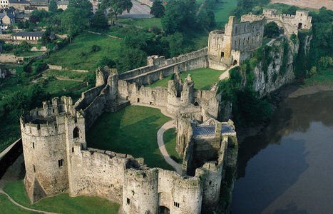

*Chepstow Castle.*

**CADW’S AIMS:**

Cadw is constantly looking to developing revenue streams in order to help support its work and to benefit local communities. One key commercial area where Cadw is keen to develop further is the provision of food and beverage across a range of sites and to provide opportunities for local businesses to work with Cadw, in relation to this.

As such, the provision of a mobile catering unit at Chepstow castle aims to provide a real and substantial opportunity, preferably for a local, independent, business.

**THE OPERATOR:**

Cadw views the use of the catering facilities within Chepstow Castle, as a long term partnership and it is therefore essential that any applicant is committed to Cadw’s aims of working to conserve and protect Wales’s heritage for us all to keep and to enjoy, both now and in the future, and to promote distinctive regeneration and sustainable development through heritage.

Cadw is looking for an applicant who must be able to demonstrate:

* The appropriate catering, hospitality, business management experience, and expertise.
* Experience of running a fast paced, high quality, visitor business, catering for many varied visitor groups and significant numbers.
* The commitment, ability, flexibility and enthusiasm to work closely with Cadw to achieve its aims, goals and objectives.
* Share Cadw’s objectives to work in partnership with Cadw and wider Welsh Government staff, businesses, and the local community.
* Evidence of consistently achieving the highest standards of customer service and a quality catering offer, all year round.
* They are preferably a local, independent business, who knows and wishes to be a part of the local community and is supportive to the local community.
* A realistic business plan and a sound financial base to provide the necessary working and investment capital.
* Recognise opportunities and can make the most of the footfall in the area and look to ensure this will complement existing local businesses.
* A good communicator, who will be an ambassador for Cadw and the local community both locally and regionally.
* They have the necessary drive and determination to succeed, can meet challenges head-on, leads their own team by example, and a team player who is adept with change.

Cadw will assess any Expressions of Interest received and along with the above, also assess the applicant’s commitment to meeting Cadw’s Service Standards Requirements, Welsh Language Requirements, Community Benefits and Cadw’s own ethos as part of the assessment of all Expressions of Interest received. This process will identify Cadw’s preferred operator who will then be given the opportunity to negotiate the finer details of the Landlord & Tenant agreement in advance of the proposed occupation date. Should agreements not be agreed by April 2023, Cadw reserves the right to approach the second preferred occupier to negotiate terms and secure an occupational agreement.

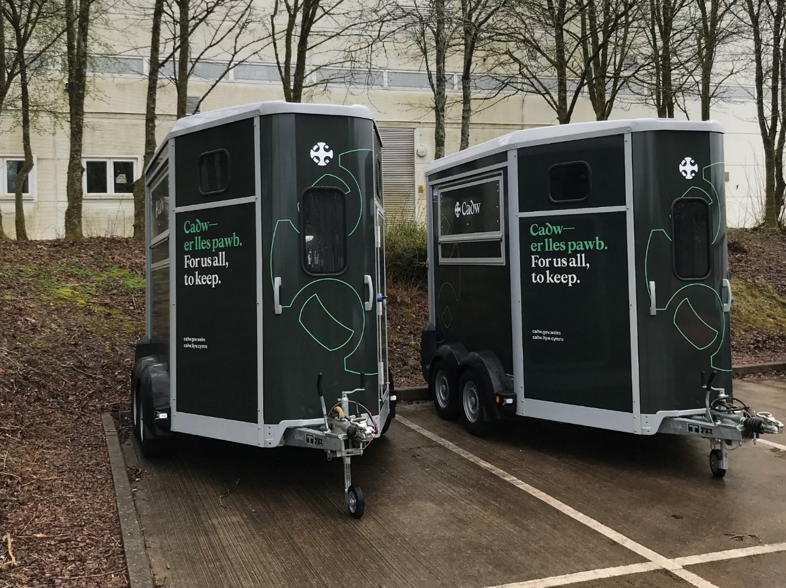

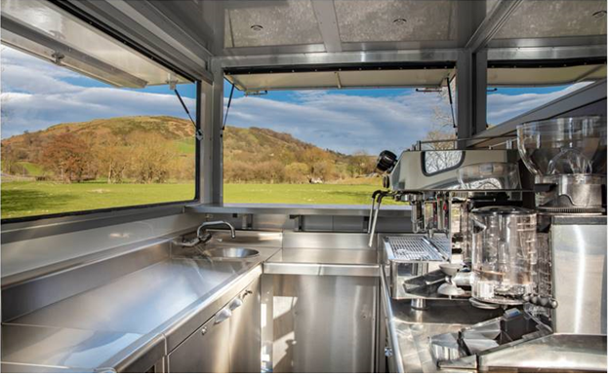

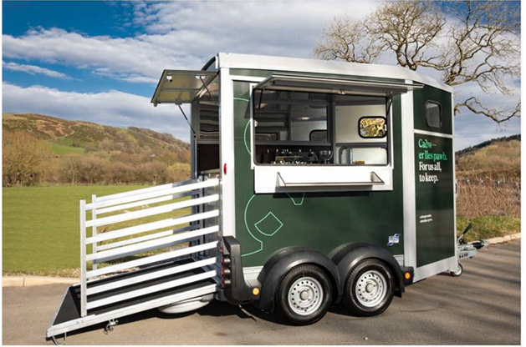

*Images of the mobile catering unit to be run by the successful Operator at Chepstow castle.*

**CHEPSTOW CASTLE EXTERNAL SPACE FOR AN OUTSIDE MOBILE CATERING UNITS AREA – 18m x 9m (Great Hall)**

This outside space provides an opportunity for the Operator to use Cadw’s mobile catering unit, (external water tap and power supply) together with space potentially for tables and chairs; there are 6 benches in the lower bailey. The area benefits from mains electricity and water supply but no drainage.

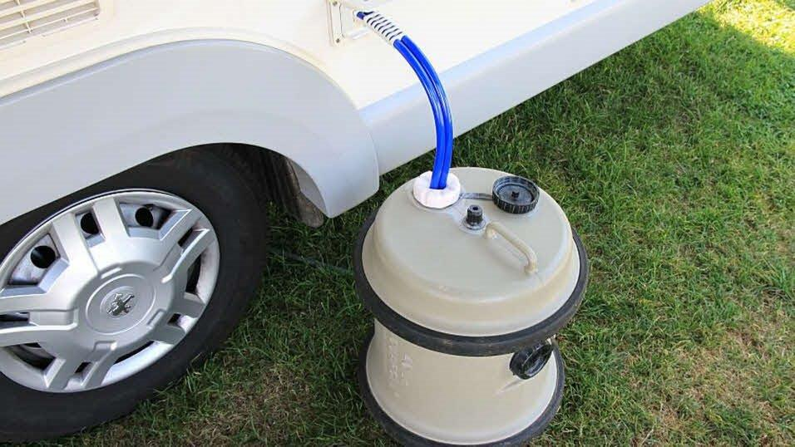

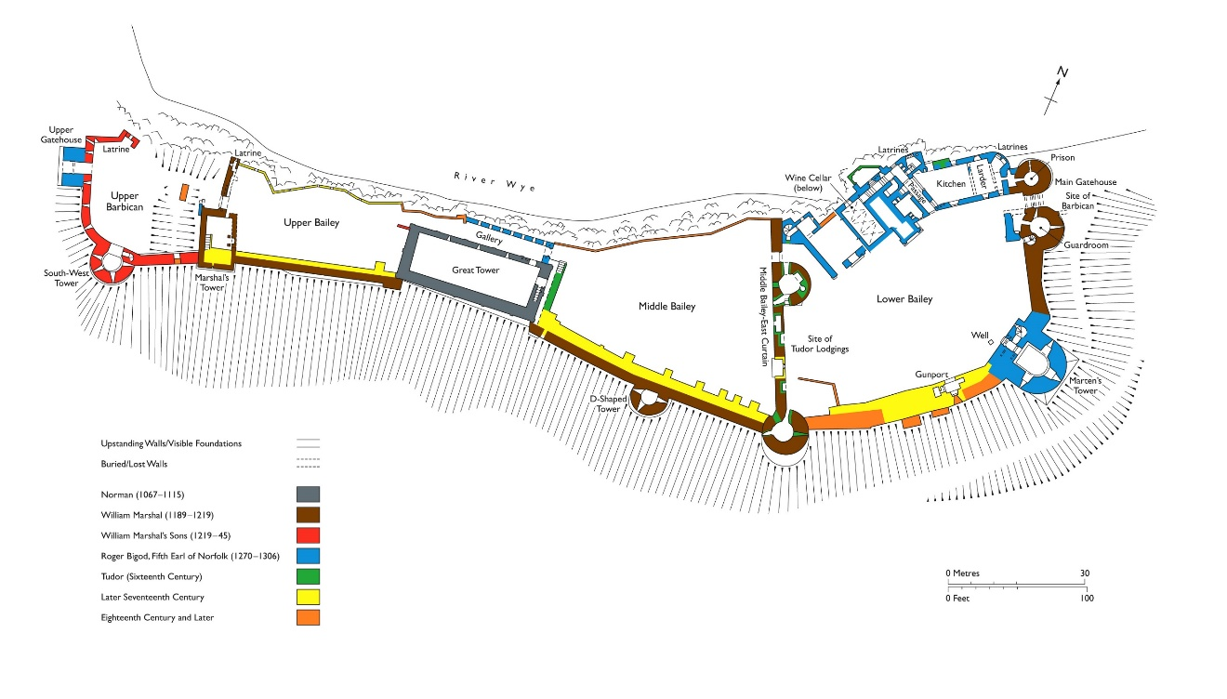

Chepstow Castle mobile catering is fully fitted with the following equipment provided as part of the occupational agreement:

**Equipment:**

* **Side service hatch and bar with shelf.**
* **Side inspection door (opposite side to serving hatch).**
* **Rear prop-stands.**
* **Insulated floor – with Altro vinyl flooring.**
* **‘False’ ceiling with internal 12V LED lights (10 spotlights) with battery and sockets for 12v electrical items.**
* **32A 230V hook up and plug sockets.**
* **Rear ramp side gates.**
* **Water Heater with 10l tank and basin for hand washing.**
* **12V water pump with bypass to allow mains water or barrels as source.**
* **Display fridge.**
* **Stainless steel units, including counter/worktop, coffee grounds knock-out drawer and bin.**
* **Coffee Machine Fracino Contempo (CON2E).**
* **Coffee grinder Fracino Model T.**
* **Display mirror.**
* **Sink.**
* **Cadw vinyl wrap.**
* **Space for ice cream machine W-440mm D-700mm H-721mm** [**http://www.blueicecreammachine.co.uk/product/t15-soft-serve-ice-cream-machine/**](http://www.blueicecreammachine.co.uk/product/t15-soft-serve-ice-cream-machine/)

**To Note:** Cadw will ensure all equipment is in good working order prior to the start of the contract. **The Operator will be required to repair and replace all equipment as listed above, for the duration of the contract.**

**The Operator is also responsible for the servicing of all equipment and infrastructure of Chepstow Castle mobile catering unit and for all general internal maintenance, to keep both the equipment and the mobile catering**

**unit in good repair.**

**VISITOR NUMBERS FOR CHEPSTOW CASTLE:**

**A total of** **58,903** visitors to Chepstow Castle for FY April 2019 – end of March 2020, split monthly as follows:

|  |  |
| --- | --- |
| April 19 | 7244 |
| May 19 | 7376 |
| June 19 | 5751 |
| July 19 | 7402 |
| Aug 19 | 9105 |
| Sept 19 | 6983 |
| Oct 19 | 4400 |
| Nov 19 | 2349 |
| Dec 19 | 2362 |
| Jan 20 | 2338 |
| Feb 20 | 1990 |
| Mar 20 (covid/lockdown) | 1603 |
| **Total:** | **58903** |

**OPENING TIMES 2022/23**

**1 March – 30th June**:

Open Daily: 9.30am - 5pm.

**1 July – 31st August:**

Open daily 9.30am – 6pm

**1 Sept – 31 October:**

Open Daily: 9.30am–5pm

**1 November – 28th February:**

Open Daily: 10 am – 4pm

Closed 24th, 25th and 26th December and 1st January.

**CADW SERVICE STANDARD REQUIREMENTS AND OPERATOR RESPONSIBILITIES:**

The successful operator will be expected to provide and adhere to the following **Service Standard Requirements** as part of this contract for Chepstow Castle mobile catering unit.

* To provide a year round high quality, efficient and effective catering service, to meet the visitor number demand, as appropriate, for a renowned Heritage Site. To complement and enhance the visitor experience and add to an overall enjoyable visit, for our visitors (currently circa 59K per year, pre-Covid). Opening hours of the mobile unit within the castle grounds can be discussed with the successful operator.
* To ensure no reputational risk to Cadw through any actions or activities by the Operator and their staff, or by any association with the catering facilities. To promote and support the work of Cadw and its aims and objectives to visitors during the length of the contract, and to support the work of Cadw Custodians and employees at Chepstow Castle.

**Produce and Suppliers:**

* An emphasis on quality products, friendly and efficient customer service, a warm Welsh welcome, availability of product, attractive and full counter displays.
* A commitment to use local, Welsh suppliers, and to support Welsh businesses, sourcing responsibly.

**The Offer:**

* For Chepstow Castle mobile catering to provide a daily, fast turnaround, catering offer, to include snacks, cakes, sandwiches etc incorporating Welsh delicacies such as Bara Brith and Welsh Cakes and a variety of hot and cold beverages. To make provision for vegetarian and vegan dietary requirements.
* To deliver a quick turnaround of customers, (especially in peak season), in order to cater for visitors to Chepstow Castle and successfully meet their expectations.

**Pricing:**

* Pricing to be accessible, with the Operator agreeing prices for their standard offer with Cadw at the outset, with any increases to be agreed in advance of any change with Cadw.

**The Welsh Language:**

* As a minimum, the Welsh Language is to be used as first language, English second and be in evidence by the Operator, in the following areas of the Chepstow Castle mobile catering unit: bilingual menus, signage (to include menu items, promotional tent cards or descriptions), and counter service. There should always ideally be a member of staff available to speak Welsh to customers. The successful Operator should ensure that in implementing the contract, the Welsh language is promoted and facilitated and not treated less favorably than English.

**Opening and Closing Times:**

* As a minimum, Chepstow Castle mobile catering to open and close in line with Chepstow Castle opening times and to adjust accordingly, if Chepstow Castle opening times are changed i.e. to open at the same time as the stated opening time for the monument, and to close, no earlier than 30 minutes before the stated closing time of the monument.
* Chepstow Castle mobile catering to open for any evening events which may arise, when asked to do so by the Client, and to provide an out-of-hours catering service if required. The frequency and nature of these events will naturally vary, but this is likely to increase in number; currently this is approximately twenty events per annum, for example, theatre performances and Castle Roc (evenings throughout August).
* The mobile unit will be situated in the area where wedding events take place (approx 10 pa in 2023-24). For a wedding event, the mobile catering unit may need to be moved to the secondary area of the site within the castle grounds, whilst the wedding takes place. The Operator will be responsible for moving the mobile catering unit on these occasions and should use the method statement in Annex A. Alternatively, the wedding couple may require a Prosecco / Champagne bar and The Operator can agree terms with them but would need to apply for an alcohol license.
* The Operator may also need to move the unit to an alternative location within Chepstow Castle during August while Castle Roc event takes place. The successful operator can negotiate with Castle Roc and events to possibly provide catering for third party events on site.

**Compliance: Food Hygiene, H&S and Allergens:**

* Ensure compliance with all relevant legislation appropriate for the operation of this contract for Chepstow Castle mobile catering, including, but not limited to the Health and Safety at Work Act 1974, Food and Environmental Protection Act 1985, Environmental Protection Act 1990, Food Safety (General Food Hygiene) Regulations 1995, the Control of Substances Hazardous to Health Regulations 2002, Food Hygiene Rating (Wales) Act 2013, Food Hygiene Rating Wales Regulations 2013 and Regulation No 1169/2011 on the Provision of Food Information to Consumers.
* All compliance paperwork in relation to the Act’s above, to be kept on site at Chepstow Castle mobile catering and to be available for inspection by Cadw, or their representatives, and the Local Authority Environmental Health Officer.
* Ensure a consistent Food Hygiene rating of level 5 for Chepstow Castle mobile catering. Any changes to the Food Hygiene rating, will need to be reported to Cadw within 24 hours and a management plan agreed and put in place, to ensure that level five is reinstated within agreed timescales.
* Failure to reinstate a Food Hygiene rating level 5, within the agreed timescales will require the Operator to work together with the Client to ensure rating level 5 is again achieved. Cadw reserves the right to undertake any required work to achieve this rating level and to seek reimbursement of any costs from the Operator.
* Co-operate with any Food Safety and Health and Safety audits, as undertaken by Cadw or their representatives.
* Catering staff for Chepstow Castle mobile catering unit, to be qualified in Food Hygiene to Level 2, with Management qualified to a minimum of Level 3 Food Supervising. Food Allergen Awareness training and Manual Handling are also to be completed, by all staff. Refresher training to be taken per annum. Staff training records and certificates to be kept on site and available to Cadw.
* Food business operators in the retail and catering sector are required to provide allergen information and follow labelling rules as set out in food law [Allergen guidance for food businesses | Food Standards Agency](https://www.food.gov.uk/business-guidance/allergen-guidance-for-food-businesses) This means that food business operators must provide allergen information to the consumer for both prepacked and non-prepacked food and drink [allergen labelling information for Prepacked for Direct Sale (PPDS)](https://www.food.gov.uk/business-guidance/introduction-to-allergen-labelling-changes-ppds); . [Natasha Ednan-Laperouse, who had an allergic reaction caused by a baguette](https://www.food.gov.uk/news-alerts/news/fsa-marks-a-year-to-go-until-allergen-labelling-changes-are-introduced) handle and manage food allergens effectively in food preparation and food businesses must make sure that staff receive training on allergens. [Allergy training for food businesses | Food Standards Agency](https://www.food.gov.uk/business-guidance/allergy-training-for-food-businesses) The Operator is to check all allergen requirements with the Foods Standards Agency and take advice from the local EHO to ensure all legislative compliance is being fully met.

**Equipment, Service and Repair Responsibilities:**

* The Operatorwill **repair and replace** the following **equipment** (but not exclusive ) for the execution of the contract for Chepstow Castle mobile catering unit: side service hatch and bar with shelf; side inspection door (opposite side to serving hatch); rear prop-stands; insulated floor – with Altro vinyl flooring; ‘false’ ceiling with internal 12V LED lights (10 spotlights) with battery and sockets for 12v electrical items; 32A 230V hook up and plug sockets; rear ramp side gates; water heater with 10L tank and basin for hand washing; 12V water pump with bypass to allow mains water or barrels as source; display fridge; stainless steel units, including counter/worktop, coffee grounds knock-out drawer and bin; coffee Machine Fracino Contempo (CON2E); coffee grinder Fracino Model T ; display mirror; sink; Cadw vinyl wrap; Space for ice cream machine W-440mm D-700mm H-721mm <http://www.blueicecreammachine.co.uk/product/t15-soft-serve-ice-cream-machine/> to a minimum agreed specification with Cadw. Any replacements are to be approved by Cadw, in advance of any purchase. All repairs and replacements are to be undertaken by qualified tradesperson, employed by a VAT registered company.
* The Operator will be responsible for the **service** of all equipment and infrastructure within the mobile catering unit at Chepstow Castle, this includes (but not exclusive), 12V LED lights (10 spotlights) with battery and sockets for 12v electrical items; 32A 230V hook up and plug sockets; rear ramp side gates; water heater with 10L tank and basin for hand washing; 12V water pump with bypass to allow mains water or barrels as source; display fridge; stainless steel units, including counter/worktop, coffee grounds knock-out drawer and bin; coffee Machine Fracino Contempo (CON2E); coffee grinder Fracino Model T; display mirror; sink; Cadw vinyl wrap; Space for ice cream machine W-440mm D-700mm H-721mm lighting and drainage to include all drain and pipe blockages. All services are to be undertaken by qualified tradesperson, employed by a VAT registered company. Dates of service and record of service paperwork to be kept on site, and to be available for inspection by Cadw, or their representatives, and the Local Authority Environmental Health Officer.
* The Operator will be responsible for all **emergency call out** work to Chepstow Castle mobile catering unit, for example, such as blocked pipes, leaking pipes, tripped electrical supplies and lighting malfunctions.
* With the Operator responsible for servicing and emergency call outs, the Operator needs to work closely with the Cadw Facilities Manager and Head and Lead Custodians, in reference to the reporting of faults, as some issues could have a profound effect on the overall daily Castle business.

**Contract Management and Financials:**

* Participate in quarterly contract review meetings with Cadw, to include quarterly sales, financials, staff training, menu, suppliers, compliance, customer feedback and actions.
* Provide all required insurance documents applicable for the operation of the contract from commencement of the contract, annually, and as requested by Cadw.
* Provide management accounts on an open-book basis, to include, but not limited to, all costs, profit/loss and turnover every 6 months and as requested by Cadw.
* The Operator will be liable for any loss of takings, if Chepstow Castle needs to close for any reason, for example, due to utility services failure, equipment failure or adverse weather conditions etc.
* Cadw will not be liable to pay the Operator compensation to cover Chepstow Castle mobile catering staff wages, for example, due to any site building works, adverse weather conditions, equipment failure or site closure for any reason.
* The Operator will be required to provide Cadw with its monthly sales turnover every 6 months, supported by till output documentation and a year-to-date turnover figure to Cadw within 15 days of 31 March and 30 September each year.
* The Operator is also required to provide to Cadw full management accounts every 12 months when complete.

**Adverse Weather Conditions and Gritting:**

* The Operator will be responsible in adverse weather conditions to grit the external areas of the Chepstow Castle mobile catering facility, with Cadw responsible for the wider site.

**Refuse and Recycling:**

* The Operator will be responsible for the management, recycling and/or disposal of all rubbish and waste material connected with the operation for Chepstow Castle mobile catering unit, and in obtaining the necessary commercial waste licenses. The licenses are to be available on site, for inspection by the Client, or their representatives, and the Local Authority Environmental Health Officer.
* The Operator will be responsible for the purchase of additional litter and recycle bins in relation to any future increase in quantities of rubbish/waste material from the Chepstow Castle mobile catering facility. The successful Operator will be required to pay the cost for the daily, emptying of bins and removal of waste from site; this cost will be charged and reviewed annually by Cadw.

**Cleaning, Cleaning Materials, Deep Cleans and COSHH:**

* The Operator shall be responsible for the cleaning and tidying of **all** catering areas, public, servery and preparation, to include all equipment, tiling, flooring, walls, light fittings, counters, tables and chairs, menus and signage of Chepstow Castle mobile catering
* The Operator will be responsible to organise and arrange for an annual certified hygiene deep clean of the Chepstow Castle mobile catering catering facility. Record of dates and paperwork to be kept on site and to be available for inspection by Cadw or their representatives, and the Local Authority Environmental Health Officer.
* To supply all cleaning materials and equipment for Chepstow Castle mobile catering and to undertake staff training in connection with this, to meet all Food Hygiene, Health and Safety, and COSSH regulations.
* To store all cleaning materials for Chepstow Castle mobile catering, to meet COSSH compliance. [**https://www.hse.gov.uk/coshh**](https://www.hse.gov.uk/coshh)
* To clean all external and internal areas of the mobile catering unit to include hatch, sides, roof, door and wheels.

**Rent and Utilities:**

* Base rent to be paid on the first day of each calendar month.
* The rent is to be payable by Direct Debit. The Operator will not be required to provide a deposit.
* The annual rent for the Chepstow Castle mobile catering unit to be paid to Cadw is to be £5,000 per annum ex VAT in 12 monthly rent instalments.
* Cadw will invoice the Operator for all utilities.
* In addition, the Operator will be responsible for all outgoings related to the mobile catering unit, and their use such as Business Rates, Council Tax, water, electricity and utility charges.
* The Operator will serve Cadw with no less than 6 months’ notice if they wish to terminate their occupational agreement within the agreement period.
* The Operator must pay in full the rent due for the notice period even if they choose to vacate the Premises beforehand, unless agreed otherwise in writing by Cadw.

**Compliance and PAT Testing and Fire:**

* The Operator will be required and responsible for, arranging (with a recognised and qualified Pest Control contractor), management and payment of, a Pest Control Service contract, for quarterly visits to Chepstow Castle mobile catering. Records of visits and outcomes by the Pest Control contractor are to be kept on site and to be made available to Cadw when requested. Any advice by the Pest Control contractor is to be acted on, by the Operator.
* The Operator will be required and responsible for, arranging, (with a recognised and qualified Fire Safety contractor), management and payment of a Fire Equipment Service contract, for annual testing, for Chepstow Castle mobile catering. Access/dates for this service work must be agreed in advance with the Head Custodian in reference to the impact, on the Court and Castle site. Records of visits and outcomes by the Fire Safety contractor are to be kept on site and to be made available to Cadw when requested. Any advice by the Fire Safety contractor is to be acted on by the Operator.
* The Operator will also be required to undertake a Fire Risk Assessment for Chepstow Castle mobile catering unit, to include a Fire Evacuation plan which incorporates any external seating areas. This plan needs to be agreed with the landlord to form part of the overall FRA for Chepstow Castle
* The Operator will be responsible for arranging and payment, of annual PAT testing (with a recognised and qualified electrician) for all catering electrical equipment, within the overall Chepstow Castle mobile catering, as part of the contract.
* It is the Operator’s responsibility and duty, to ensure these and all other compliance measures are taken and implemented to meet the legal requirement.

**Non- Domestic Council Tax:**

* In addition, all other charges such as non-domestic council tax will be the direct responsibility of the Operator. It is the duty of the Operator to establish these costs directly with the local authority.

**Staff Uniforms:**

* Ensure catering staff for Chepstow Castle mobile catering, wear an appropriate uniform suitable for catering, and have name badges, identifying them as employees of the catering Operator. Cadw is to be consulted on the choice of uniform and their approval obtained, prior to purchase. All signage and uniform must be in line with Cadw branding on the site.

**Accident Reporting:**

* The Operator and members of their staff are first aid trained they will need to ensure they maintain their first aid certificate and provide / manage their own first aid kit, providing first aid for their own staff and customers. For major accidents, the Operator will coordinate with the Head / Lead Custodian on duty at that time, who can assist with any access issues for emergency services / cordoning off from public.
* If any of the Operator’s staff working at the mobile catering unit, on any particular day, are not first aid trained, first aid cover will need to be supplied by the site. Effective means of communication needs to be maintained between both teams i.e.via radios as agreed by the Head/Lead Custodian. The same record keeping principals will apply.
* Any accidents by the Operator’s staff, are to be recorded on the Cadw Accident reporting system as soon as they occur. The Operator can use Cadw’s Accident Investigation Report (AIR) form; a version is to be kept at the relevant catering facility at site, by the Operator, and a copy submitted to the Cadw safety team.

**Induction:**

* The Operator to carry out an induction process for any new staff for Chepstow Castle mobile catering and introduce them to the Cadw Head Custodian, Lead Custodians and Custodians.
* The Operator is required to attend a site induction for Chepstow Castle, as included in the catering lease, and to follow through on all induction requirements for themselves and their staff, within the timescales agreed at the induction.

**Fair Working Practices:**

* Ensure that fair working practices are being implemented throughout the term of the contract. Fair work practices may include (this is not an exhaustive list):
* A fair and equal pay policy that includes a commitment to paying all staff at least the voluntary Living Wage set by the Living Wage Foundation ([http://www.livingwage.org.uk](http://www.livingwage.org.uk/))
* Becoming an accredited Living Wage employer.
* Ensuring that all staff have access to training and development opportunities
* Promoting equal opportunities for all staff regardless of age, gender, disability, religion, race and sexual orientation.
* Stable employment, avoiding inappropriate use of zero-hours contracts.
* Flexible working arrangements to allow support for carers, and for family friendly working.
* Supporting workforce engagement, for example Trade Union recognition and representation, or other arrangements for empowering staff.

**Community Benefits:**

Cadw is striving to develop a vibrant Welsh economy capable of delivering strong and sustainable economic growth, by providing opportunities for everyone in Wales, and in particular, local communities. Sustainable development is ensuring our actions contribute to social, economic and environmental well-being both now and in the future. The successful Operator will need to demonstrate how they aim to achieve this during the course of their contract, working together with Cadw, to build stronger communities, reduce social exclusion and poverty, to improve the environment and to encourage growth of the local and the Wales wide economy.

Cadw’s commitment to deliver ‘community benefit’ outcomes from our procurement activity is designed to ensure that wider social and economic issues are taken into account when spending public money. The intention is to achieve the very best value for money in the widest sense**.**

**The priorities to address:**

The Community Benefits Policy has key strategic priority areas that align with the Welsh Government Programme for Government commitments. The policy priority areas that the Client wants Operators to cover, are:

* Training and recruitment opportunities for the economically inactive/ disadvantaged groups, including Worklessness (Welsh Government Lift Programme), and/or graduates, under graduates’ placements and/or trainees, and/or apprenticeships etc.
* Bidders should consider opportunities for recruiting and training the above groups as part of the workforce delivering this contract / agreement.
* Retention and training for the existing workforce.
* Promotion of Environmental Benefits.

*Long-term economically inactive’ in this invitation means those who have not been in paid employment in the last 3 months immediately prior to the date of this invitation. For the definition of disadvantaged please refer to the EU definition which can be found in the community benefits measurement tool, employment tab at this link <http://prp.wales.gov.uk/toolkit/>

**Environmental statement:**

* Cadw is committed to minimising the effect of its day-to-day operations on the environment and the Operator will be encouraged to adopt a sound, pro-active, environmental approach, designed to minimise harm to the environment.

Factors to be considered should include areas such as:

* Adopting an environmental management system which includes focus on disposal of waste and packaging.
* No to single use plastics.
* Use of environmentally cleaning products.
* More efficient use energy and water.
* Beginning to embed sustainability into the provision of goods and services supplied to the Cadw.
* Use of recycled paper containing only post-consumer waste for all non-specialist printing whenever possible.
* Reduction in carbon dioxide emissions from business travel by extending use of video conferencing and encouraging the use of low emissions vehicles.

Building an environmentally friendly work culture through training and high-quality communication with staff.

**AWARD OF OCCUPATIONAL AGREEMENT EVALUATION:**

The successful operator will be identified from the Expressions of Interest received by the closing date and offered an occupational agreement based on the following criteria, which are listed in order of importance including the weighting applicable to each criterion. The information provided by applicants for each *individual* criterion (within the Technical Evaluation Criteria) is to be limited to the number of words specified, any additional information provided above the word count will not be considered as part of the evaluation.

**EXPRESSION OF INTEREST PROCESS: TECHNICAL EVALUATION CRITERIA.**

Please provide a methodology of how you will manage Chepstow Castle mobile catering unit operation. This should include how, drawing on your experience and expertise:

|  |  |
| --- | --- |
| * You will meet **each** of the **Service Standard Requirements** as set out above in the ‘Service Standard Requirements and Operator’s Responsibilities’ section, as part of this specification. * You will deliver the **food service requirements** in terms of its suitability for a historic site with substantial visitor numbers, including details of proposed menu, suppliers, and pricing strategy for the mobile catering unit. * You will manage Chepstow Castle mobile catering unit to ensure high, quality **food service and excellent customer service** are delivered consistently, all year round. * You will measure **customer satisfaction** and use this feedback to improve customer service. * Provide your proposed **staffing levels** (for peak and low season) and details of **key** personnel who will be responsible for the management and operational running, of the mobile catering unit. * How you will meet **additional** demands on staffing, such as special events and evening events. * How you will demonstrate you are a **local** and **independent** business. * How you will undertake food hygiene, allergen, and all H&S **staff training** and **induction.** * You will manage Chepstow Castle mobile catering to ensure all food hygiene, food safety, environmental, fire and health and safety, **compliance** requirements are met. * You will undertake all **repairs, emergency call outs,** **replacing and service requirements** of the equipment for Chepstow Castle mobile catering. * You will meet the Welsh Language requirements for Chepstow Castle mobile catering unit. * How you will demonstrate an environmentally friendly business approach. * **Covid** safe systems of work and mitigating measures. | **Weighting.**  **50%**  (maximum 2000 words) |
| Fair Work Practices   * Welsh Government is a Living Wage employer. Please describe how you will ensure that all workers engaged in the delivery of this contract will be subject to fair work practices and receive fair payment. | **5%**  (maximum 500 words) |
| Community Benefits   * How your operation can meet the community benefits re ‘The Operator’ and ‘The Cadw Service Standard Requirements and Operator Responsibilities’ sections of this specification. | **10%**  **(**maximum 500 words) |
| **Commercial Evaluation Criteria**   * Annual rent to be paid; demonstrate how viable the rent levels of £5000 rent for the mobile catering unit, will be covered against predicted sales, operating budget and cash flows for the first 3 years and your existing financial standing. Provide detail of your experience in the hospitality and catering industry and your CV. | **35%**  (maximum 850 words) |

**TIMETABLE OF EVENTS:**

Cadw has produced an indicative timetable of events that will ensure the evaluation is completed on schedule.

|  |  |
| --- | --- |
| **Date** | **Milestones** |
| Issue of Expression of Interest Notice | Wk. comm. 3rd Jan, 2023. |
| Deadline for Requests to Attend the Viewing Day | 5th February, 2023. |
| Viewing Day | 15th February, 2023. |
| Deadline for Expressions of Interest to be received by Cadw | 26th February, 2023. |
| Interviews | 8th March, 2023. |
| Evaluation of Bids | Wk comm. 13th March, 2023. |
| Award of Occupational Agreement for Chepstow Castle Mobile Catering Unit | Wk comm 13th March, 2023. |
| Agreement Start Date for Chepstow Castle Mobile Catering Unit | 1st April, 2023 |

|  |  |  |  |  |  |  |  |  |  |  |  |  |  |  |  |  |  |  |  |  |  |  |  |  |  |  |  |  |  |  |  |  |  |  |  |  |  |  |  |
| --- | --- | --- | --- | --- | --- | --- | --- | --- | --- | --- | --- | --- | --- | --- | --- | --- | --- | --- | --- | --- | --- | --- | --- | --- | --- | --- | --- | --- | --- | --- | --- | --- | --- | --- | --- | --- | --- | --- | --- |
| **THE OCCUPATIONAL AGREEMENT:**   |  |  |  |  |  | | --- | --- | --- | --- | --- | | Term:  Rent  Rent Reviews | | The occupational agreement for Chepstow Castle mobile catering unit will start from 1st April, 2023 and will run for 3 years until 1st April, 2026, with a review after year one where either party can terminate the agreement. If the relationship between Cadw and the Operator proves successful, the three-year term will be able to be extended in line with normal Landlord and Tenant negotiations   |  | | --- | | £5000 per annum basis plus VAT. The rent is to be payable by Direct Debit monthly in advance. The first rental payment will be due on the 1st day of the term.  The rent will be payable for the first year with a review after this initial period carried out as part of the negotiations surrounding the operation of the Chepstow mobile unit, and then in accordance with the terms of the agreement. | | | | Deposit:  Insurance: | | The Operator will not be required to provide a deposit.  The Client will insure the structure of the buildings with the Operator responsible for contents, fixed equipment, employee and third-party insurance. | | | Repairing Responsibilities: | | The Operator will **repair and replace** all equipment as listed in the ‘Cadw Service Standard Requirements and Operator Responsibilities’ section, and in orange above, for the duration of the contract.  The Operator is also responsible for the **servicing** of all equipment and infrastructure of Chepstow mobile unit, **emergency call outs** and for **all general maintenance**, to keep both equipment and the internal of the unit in good repair. | | | Sub Letting: | | There will be no right to assign, sub-let or part with possession of the whole or any part of the unit. | | | |  |  | | --- | --- | | Outgoings:  Notice Period:  On Site Services: | The Operator will be responsible for all outgoings related to the property and their use such as Business Rates, Council Tax, water, electricity, and utility charges.  The Operator will serve Cadw with no less than 6 months’ notice if they wish to terminate their occupational agreement within the agreement period.  The Operator must pay in full the rent due for the notice period even if they choose to vacate the Premises beforehand, unless agreed otherwise in writing by Cadw.  The Operator will have access to a toilet for use by their staff together with ancillary spaces for the storing of refuse. These will be detailed in the Occupational Agreement. | | | | | | **APPLICATION PROCESS:** | | | | | Requests to Attend Viewing Day:  Viewing Day:  Date for Receipt of Expressions of Interest: | | **Deadline for Requests to Attend the Viewing Day: 5th February 2023.**  Requests to attend the Viewing Day must be received at Cadw Commercial Mailbox [**cadwcommercial@gov.wales**](mailto:cadwcommercial@gov.wales)  Requests should be marked ‘**Request to Attend Chepstow Viewing** **Day’** and sent for the attention of Ruth Burrows, Cadw Commercial Manager.  Requests to attend the Viewing Day are to include your full contact details, name, business name, position, and business address.  **15th February, 2023** Cadw staff will be available to provide access to the site. NB. Numbers and viewing time will be limited.  **Deadline: 26th February, 2023.**  Completed applications must be received at: Cadw Commercial Mailbox [**cadwcommercial@gov.wales**](mailto:cadwcommercial@gov.wales)  Applications should be marked, ‘**Chepstow Castle Mobile Catering Unit, Application, Private and Confidential’** and sent for the attention of: Ruth Burrows, Cadw Commercial Manager.  The application must bear the applicant's signature, certifying that the information given is correct with applicants looking to include **estimated sales, budgets and cash-flows for the first three years.**  Prospective Operator’s should include information in reference to their **qualifications, relevant experience and business plan for Chepstow Mobile Catering Unit, to include their CV as part of their application**.  Applicants should also include information as to the assets they will be bringing to the business, along with income and sources of capital available for investment. | | |  | | Cadw wishes to ensure that Operators have the necessary financial standing and resources to meet their obligations throughout the duration of this contract and it should be noted that **financial checks** of your existing business will be undertaken as part of the Expression of Interest process. In addition, this may also include (where appropriate) considering your level of existing work commitments and the potential impact on resources that awarding a contract would have. In deciding to tender for a contract, you should also be aware and take in consideration the risks of becoming over- reliant on Cadw’s business, or indeed that of any customer. In doing so, you should take into account earnings from any other work undertaken for Cadw as well as potential earnings from this contract.  Applicants may use a professional agent to assist in the preparation of their application, but this should be declared and applicants should be absolutely certain that they know and agree with what is written.  **Cadw reserves the right not to accept the highest or indeed any Expression of Interest received.** | | | Selection Process: | | All applications received on or before the Expression of Interest deadline will be considered and a shortlist prepared.  Those shortlisted will be asked to attend an interview. Interviews will be held on sitewith invites to join, sent in advance of the interview date.  The interview panel will include Zara Cottle, Cadw Senior Commercial Manager; Ruth Burrows, Cadw Commercial Manager; Emyr John, Cadw Senior Estates Surveyor; Phil Brown, Cadw Head Custodian, Chepstow Castle, Nathan Wilcox, Cadw Facilities Manager. A further shortlist may then be prepared, and a second interview may follow.  Following the selection of the successful applicant, financial checks of your existing business will be undertaken, and negotiations will take place to agree the final content of the Commercial Tenancy agreement which will be initially drafted by Welsh Governments legal representatives. | |   **To note:**  It should be noted, these particulars are for guidance purposes only and are only intended to give a summary of the opportunity at Chepstow and does not constitute part of an offer or contract. All persons view the property entirely at their own risk and Cadw will accept no liability for loss, damage or injury howsoever caused. All descriptions, dimensions, images etc. contained in this document and/or given through discussions with Cadw are given as indications without responsibility and any interested parties should not rely on them as statements or representations of fact but must satisfy themselves by inspection or otherwise as to the correctness of each of them. Cadw reserves the right not to accept any expression of interest received and does not bind itself to accepting the highest financial offer. Prospective Operators are encouraged to make their own enquiries in respect of any necessary planning requirements for the intended use.  **Cadw reserves the right of not having to accept any offer received for Chepstow mobile catering unit.**  **All expressions of interest must be sent to** [**cadwcommercial@gov.wales**](mailto:cadwcommercial@gov.wales) **to be received not later than 26th February, 2023.**  Also, please visit our website [**https://cadw.gov.wales/**](https://cadw.gov.wales/) |
| **ANNEX A**  **Method statement for moving mobile catering unit:**  **Chepstow Castle Pop Up Catering Method Statement**  1. The Task involves work in the following areas:  Installing and removal of pop-up catering facility in Chepstow Castle.  2. Reference Drawings and Information  Limiting Factors or High Risk Elements To Be Undertaken.  Not Applicable  5. Safe System of Work  Personnel involved in transportation must be trained, licensed and competent in towing vehicles. Personnel are responsible for liaison with site staff and visitors to ensure safe entry and removal of unit during opening hours. Ginger should provide a Risk Assessment for Cadw’s approval.  6. Method  The area where the pop-up catering is to be placed in in what was previously used as a Great Hall in the Lower Bailey of the castle.  The width of the entrance to the area is 190cm. The width of the pop up is 176cm.  The horsebox will be pushed in by hand by two men with another man at the front to guide it, one other person needed to ‘lookout’ for any obstacles or visitors.  To protect the stonework of the walls to the entrance, the operator will place Hardwood Plywood Boards measuring (L)2.44m (W)1.22m (T)18mm against to walls, to provide extra protection, when the horsebox is moved into that area. The protective boards are 244cm long and will lie on the floor. They are 122cm tall and can rest against the wall.  To provide extra protection to the grass area, rubber matting will be placed on top of it for the vehicles to move over.   |  |  | | --- | --- | | Chepstow Requirements | HB403 width 1.76m  Chepstow Great Hall Courtyard - 190cm wide doorway. | | Tyres | 155R13C / 165R 13C | | Maximum Weight | 1600KG | | Unladen Weight | 767KG | | Overall Height | 2.70m | | Overall Width | 1.76m | | Overall Length | 4.36m | | Internal Height | 2.20m | | Internal Width | 1.30m | | Internal Length | 3.08m | | Stall Width | 1.30m | | Stall length min/max | 1.48/1.86m | | Breast/breeching bar height | 1.11/1.32m |     **ENDS** |