**Staffed Site Educational Visit – Risk Assessment Template**

Cadw is committed to welcoming Educational Visits to our sites. Please visit our [website](https://cadw.gov.wales/learn/education/education-visits) to find out more information on booking your visit.

All educational establishments visiting a Cadw site must submit a risk assessment. We have developed this example risk assessment, which can be used as a guide. We ask that you submit your risk assessment at least two weeks prior to your visit.

Cadw offer free pre-inspection visits to support the development of your risk assessment. This document is for your guidance only, you remain responsible for your risk assessment and any omissions.

If the trip involves visits to multiple sites, only one risk assessment is required as long as the individual site risks are captured.

**Booking Details**

|  |  |
| --- | --- |
| Location of trip: |  |
| Name of educational establishment: |  |
| Booking reference number: |  |
| Name of risk assessor and contact details: |  |
| Date of visit: |  |
| Number of individuals attending site (include students, teachers / chaperones): |  |

**Risk Assessment Matrix**

Likelihood **x** Severity **=** Risk Rating

***Example:*** The likelihood of someone falling over being possible (L2) multiplied by the severity of the expected injury which would be minor (S2) would give you a total risk rating of 4 which is ‘low risk’ (L2 x S2 = R4)

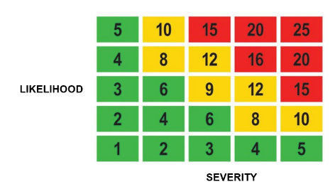

|  |  |  |  |
| --- | --- | --- | --- |
|  | **Severity** | **Likelihood** | **High Risk: 15 to 25** – Activities should cease immediately until further control measures are implemented to mitigate the risk.  **Medium Risk: 8 to 12** – Activities should only be tolerated for the short-term, whilst further control measures are being planned and introduced, within a defined a time period.  **Low Risk: 1 to 6** – Largely acceptable, subject to periodical review. |
| **S1 – No Injury** | **L1 – Unlikely** |
| **S2 – Minor Injury** | **L2 – Possible** |
| **S3 – Injury requiring hospital treatment** | **L3 – Likely** |
| **S4 – Major Injury** | **L4 – Probable** |
| **S5 - Fatality** | **L5 – Certain** |

| **Hazards**  *(what could cause harm)* | **Who might be harmed and how?**  *(who is involved in the activity and how could they be injured as a result)* | **Current control measures already in place**  *(what is already being done to reduce the risk of harm)* | **Risk rating**  *(L x S = R)* | **Further control measures required**  *(is there anything else that needs to be put in place, in addition to what has already been done, to reduce the risk even further?)* | **Risk rating**  *(L x S = R)*  *(New risk score after additional controls have been taken into account)* |
| --- | --- | --- | --- | --- | --- |
|  |  |  |  |  |  |
|  |  |  |  |  |  |
|  |  |  |  |  |  |
|  |  |  |  |  |  |
|  |  |  |  |  |  |
|  |  |  |  |  |  |
|  |  |  |  |  |  |
|  |  |  |  |  |  |
|  |  |  |  |  |  |